Student Mentor Bio Example

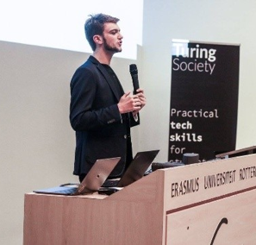
Jannes Klaas, VP of Education at OxAI

Experience

Jannes has experience working with clients in the financial industry. He created a course on machine learning for finance in the Netherlands and has written a book “Machine Learning for Finance”. His research interests include machine learning in financial regulation as well as gradient free optimization.

Areas of Expertise

Deep Learning, Tree-Based Methods, Model Interpretation

Education

Jannes is an MSc candidate in financial economics at Saïd Business School, University of Oxford

Availability

Available live at Foundry All day Saturday and Sunday Morning

